# **Descriptive Statistics**

You can find the solution to this problem in the Descriptive Statistics.xlsx file

Interpreting the Results

* **Paid-plan Students**

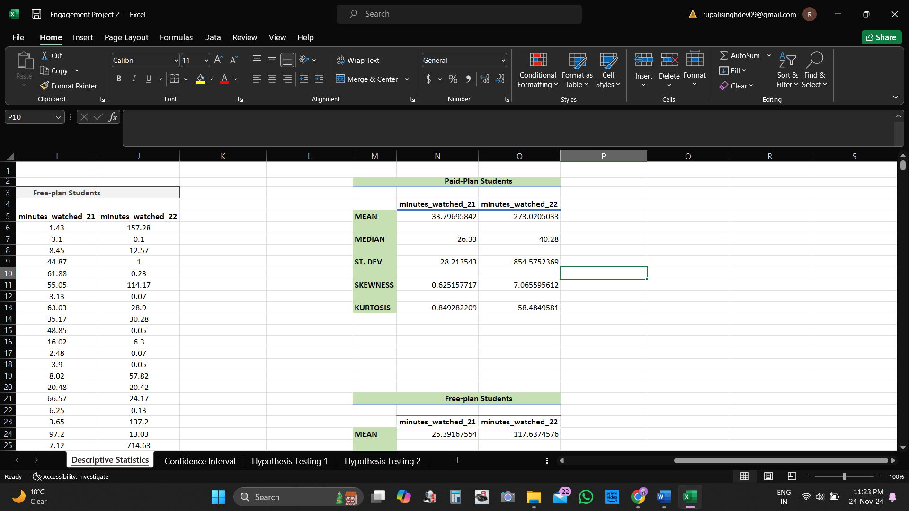

* **Mean**: Among students who watched between 1 and 100 minutes in 2021, the average minutes watched by paid-plan students increased significantly from Q4 2021 to Q4 2022, from approximately 33.80 minutes to about 273.02 minutes. This suggests a substantial increase in engagement among this group of initially low-engagement-paid-plan students.
* **Median**: The median minutes these low-engagement-paid-plan students watched increased from Q4 2021 to Q4 2022, from 26.33 minutes to 40.28 minutes. While this increase is not as dramatic as the increase in the mean, it indicates that the typical student in this group (i.e., the student in the middle of the distribution) also increased their engagement. This suggests that the increase in engagement was more widespread among paid-plan students and not solely driven by a few outliers.
* **Standard Deviation**: The standard deviation for these low-engagement-paid-plan students increased substantially from 28.21 minutes in Q4 2021 to 854.58 minutes in Q4 2022. This indicates a much larger variability in the minutes watched by these students in Q4 2022 compared to Q4 2021. This could be due to a broader range of engagement levels among the students in Q4 2022, with some students watching very little content and others watching a lot of content.
* **Skewness:** The skewness increased from 0.63 in Q4 2021 to 7.07 in Q4 2022, indicating **positive skewness**. An increasing skewness suggests that more students watch significantly more content than most over time, pulling the mean upwards.
* **Kurtosis:** The kurtosis increased from -0.85 in Q4 2021 to 58.48 in Q4 2022. Kurtosis values greater than 0 indicate that the data has heavier tails and a sharper peak than the normal distribution (leptokurtic). A leptokurtic distribution has a high positive kurtosis, suggesting that it’s very peaked and has a relatively large number of outliers. This type has a higher frequency of extreme values or outliers.
* **Free-Plan Students**

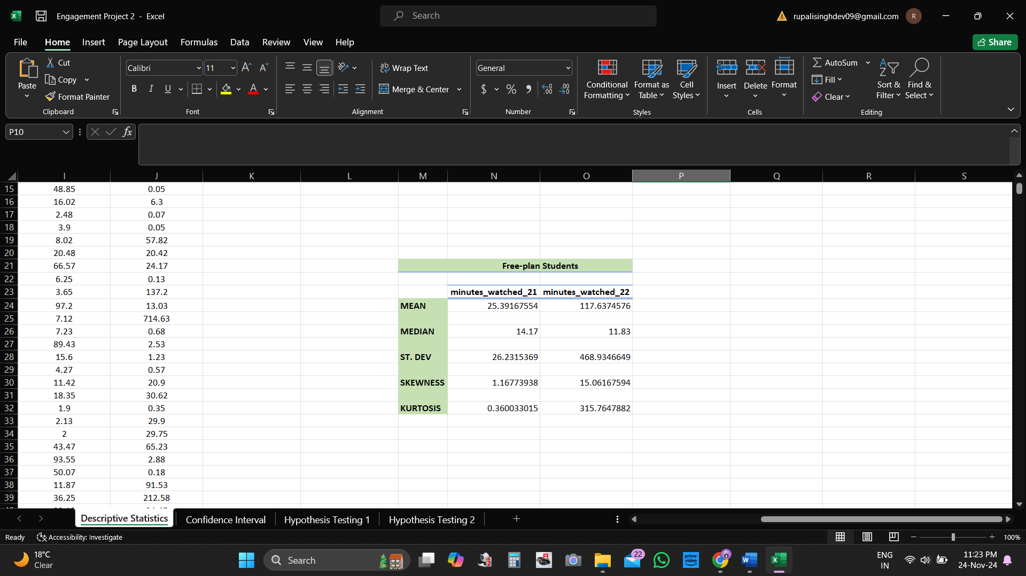

* **Mean:** Among students who watched between 1 and 100 minutes in 2021, the average minutes watched by free-plan students increased from about 25.39 minutes in Q4 2021 to about 117.64 minutes in Q4 2022. This suggests that overall engagement among these initially low-engagement-free-plan students increased during this period. But the extent of this increase is less than what was observed for similar low-engagement-paid-plan students, suggesting that while these free-plan students are watching more content, they're still not as engaged as the equivalent group of paid-plan students.
* **Median:** Interestingly, the median minutes watched by these low-engagement-free-plan students decreased from Q4 2021 to Q4 2022, from 14.17 minutes to 11.83 minutes. This indicates that engagement decreased for the typical student in this group (i.e., the student in the middle of the distribution). The increase in the mean might be driven by a small number of free-plan students who significantly increased their engagement in Q4 2022, while the majority did not increase their engagement or even reduced it.
* **Standard Deviation:** The standard deviation for the low-engagement-free-plan students increased from 26.23 minutes in Q4 2021 to 468.93 minutes in Q4 2022. This indicates a more significant variability in the minutes watched by these students in Q4 2022 compared to Q4 2021. The behavior of these students then became more diverse in Q4 2022, with some watching a lot of content and others watching very little.
* **Skewness:** The skewness for **free-plan students** increased from 1.17 in Q4 2021 to 15.06 in Q4 2022, indicating positive skewness.
* **Kurtosis:** The kurtosis increased from 0.36 in Q4 2021 to 315.76 in Q4 2022. The increase in kurtosis over time suggests more extreme cases in the data in Q4 2022 than in Q4 2021.

**Conclusion**

On average, low-engagement-paid students initially increased their watching time more significantly than the free-plan students from Q4 2021 to Q4 2022. This could suggest that paid-plan students find more value in the platform, possibly due to premium features or content that are available to them. In contrast, the median watch time decreased for free-plan students, suggesting that the typical free-plan student in this group did not increase their engagement.

Overall, the increasing skewness and kurtosis for both groups from Q4 2021 to Q4 2022 suggest a growing number of students watching significantly more content than the majority. This is especially true for free-plan students with a higher skewness and kurtosis in Q4 2022 than paid-plan students.